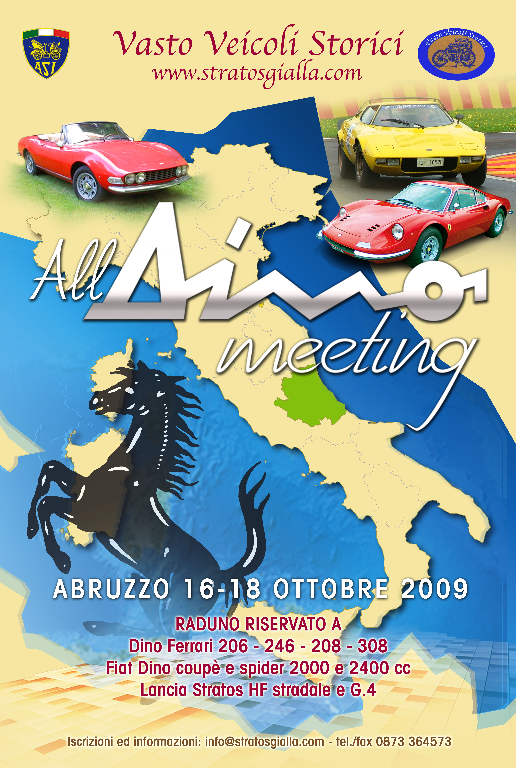

Price and informations

The « All Dino meeting » will be on October the 16-17 and 18 whith the annexed program.
Le meeting will be composed of turistic tours whith chrometred specials trials on street closed where is possible, on Friday afternoon. The all day of Suturday will be in the circuit of Sant’Egidio alla Vibrata, for chronomered specials trials and exhibitions of very important guests. In the Sunday specials trials will be done in Civitella del Tronto.
For a limited number of people it is possible the iscription without car, the price include all same the normal insription. Between the people without car will be share same tours on circuit as passenger in the guest cars (Lancia Abarth 037, Lancia Abarth S4, Lancia Delta Abarth, Stratos etc.)
During all meeting le login will be on l’Hotel Casale via Casale Superiore 146 63030 Colli Del Tronto (AP) Italia (www.hotelcasale.it)
The Hotel has big parking also for track. The Hotel has wellness center and swiming pool in door with hot water.
The prices, all charges included, are:
- Two persons on double room 890 Euro
- For only one person 550 Euro
- For one kid on third bed 250 Euro
- For suplementar person 450 Euro
- Suplentar charge for two singles rooms 150 Euro
- For ech. suplementar night on double room 125 Euro
Frigo bar free, all drinks and the show of gala dinner are included without supplementars charges.
For Club or groupe that will make comulatives inscriptions will be free one inscription every ten.

Service whitout suplementars charges:
- Rescue transport to the Hotel or locale Shop
- Emergency tecnical assistance mecanical and electrical
- Assistence for tyres
- For partipants without car displacements on little bus (18 place)
Services with charge:
- Gasoline with 110 ott. (order by 5lt) 5 Euro/lt
- Personal Photo book (to be order on inscription)

For all suplementars informations next will be operative the web site:
www.alldinomeeting.com
Actuals contacts :
Email: info@stratosgialla.com tel./fax 39 0873 364573
Pers. phone of President of C.O. Massimo Leone 39 380 3021236

“ All Dino meeting”
Programme

Friday October 16
From 8,30 h to 12,30 h arrival, discharged of tracks, inscriptions
verifications and check in at the Hotel Casale
From 12,30 h to 14,00 h dinner and breefing
From 14,00 h departure (one every minut)
Turistic tour for abaut 100 km whith 20 chronometerd specials trials
From 19,00 h return to theHotel
From 20,30 h supper
Suturday October 17
From 9,00 h departure for the circuit ( Sant’Egidio di
Val Vibrata)
From 9,30 h chronometerd specials trials on circuit
From 12,30 h dinner on circuit restaurant
From 14,30 h chronometerd specials trials on circuit
From 18,00 h final trials and exibitions of guests
From 20,30 h return to theHotel
At 21,30 h gala supper with show
Sunday October 18
From 7,30 h to 9,00 h check out from th Hotel
From 9,00 h departure (one every min.) for Civitella del T.
From 9,30 h to 10,20 cocktail
From 10,30 h to 12,30 h Specials trials at Civitella del Tronto
From 13,00 h dinner, rewarding and end of meeting

Rules of inscription
Art. 1- The inscription is subjet to the inconditioned decision of the
Organization.
Art. 2- The documents 1,2 and 3 of demand of inscription correctly
subscribed must be sended to:
by mail to :“All Dino meeting” via Laccetti n° 15
66054 VASTO (CH) ITALY
by fax to : 39 0873 364573
by e-mail to: info@stratosgialla.com
Art. 3- After reception of acceptance of demande of inscription
(by fax or e-mail) the Participant must pay by bank 350 Euro ( the
bank codes will be send with the acceptance). The rest of the
payement must be done on arrival the October 16 morning.
Art. 4- In case of annulation, the payement will be rendered with the
only reduction of bank claims, if the allulation will be made berore
the Sept. 15. If the annulation will be made after the September 15
the anticipation will be not rendered at all.
Art. 5 –The Participant guarrantee that the all informations gived on
documents of inscription are corrects.
Art. 6- For the trials on circuit it is necessery to use homologueted
casque
Art.7-The Organisation guarratee that the program will not reduce, but
same modifications of the program can be done without advice,
if it is strictly necessary.

Date...................................Signature (legible)....................................
Document 1

Document 2
Demand of inscription
Car: Mark____________________model_________________________
Cylind.________________color_________________years____
Homologations_________________________________________

Driver:____________________________________________________
Adresse_______________________________________________
Teleph._____________________e-mail____________________
Size___________________________

Codriver:__________________________________________________
Adresse_______________________________________________
Size___________________________

Passengers__________________________

Login: double room________________single room___________
Third bed__________________Supplmentars nights________

Option Gasoline 110 oct. (by 5lt)____________________

Date __________________________Signature___________________

Document 3

